# [SourceTree 免登录跳过初始设置](http://www.cnblogs.com/xiofee/p/sourcetree_pass_initialization_setup.html)

**http://www.cnblogs.com/xiofee/p/sourcetree\_pass\_initialization\_setup.html**

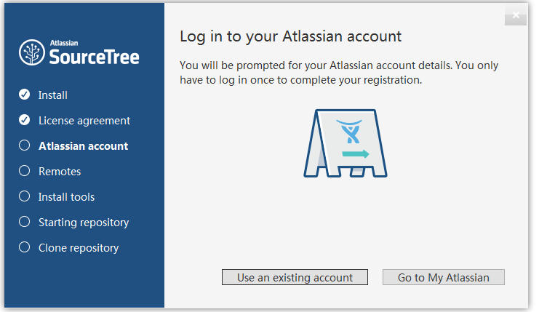

SourceTree 安装之后需要使用账号登陆以授权，以前是可以不登陆的，但是现在是强制登陆。

虽然是免费授权，但是碰上不可抗力因素，登陆不是很方便，这里记录一下跳过这个初始化的步骤。

安装之后，转到用户本地文件夹下的 SourceTree 目录，没有则新建

%LocalAppData%\Atlassian\SourceTree\ --在我的电脑输入可以找到目录

新建 accounts.json 文件

%LocalAppData%\Atlassian\SourceTree\accounts.json

输入以下内容保存即可

[IMG_256](http://www.cnblogs.com/xiofee/p/javascript:void(0);)

[

{

"$id": "1",

"$type": "SourceTree.Api.Host.Identity.Model.IdentityAccount, SourceTree.Api.Host.Identity",

"Authenticate": true,

"HostInstance": {

"$id": "2",

"$type": "SourceTree.Host.Atlassianaccount.AtlassianAccountInstance, SourceTree.Host.AtlassianAccount",

"Host": {

"$id": "3",

"$type": "SourceTree.Host.Atlassianaccount.AtlassianAccountHost, SourceTree.Host.AtlassianAccount",

"Id": "atlassian account"

},

"BaseUrl": "https://id.atlassian.com/"

},

"Credentials": {

"$id": "4",

"$type": "SourceTree.Model.BasicAuthCredentials, SourceTree.Api.Account",

"Username": "",

"Email": null

},

"IsDefault": false

}

]

[IMG_257](http://www.cnblogs.com/xiofee/p/javascript:void(0);)

现在再打开 SourceTree，直接显示主窗口了